Adventure, Yoga, and Service Retreat

February 22-29, 2020

Trip Leaders/Yoga Teachers:
Lynda Schoberth and Maryjane Behforouz

ITINERARY
Day 1 – Saturday
Arrive in San Jose, Costa Rica and transfer to the 4-star hotel, Don Carlos, in the city. Get settled in your new surroundings until the Welcome Dinner at 6 p.m. at the hotel’s restaurant, Café Amon. (D)
Accommodations:
Located in the oldest historical section of San José, the ‘Four Star’ Hotel Don Carlos is a small, but significant part of Costa Rica’s rich heritage. Once upon a time residence for two past Presidential families, the historical Hotel Don Carlos’ warmth and charm, graciously awaits you. Enjoy Costa Rica’s finest art works as you stroll through the gallery-like corridors and maze of quiet garden and fountain settings, restaurant and mini pool. Wander into Annemarie's Boutique and get lost within this unique world of local artistic creations in Costa Rica's #1 gift shop.

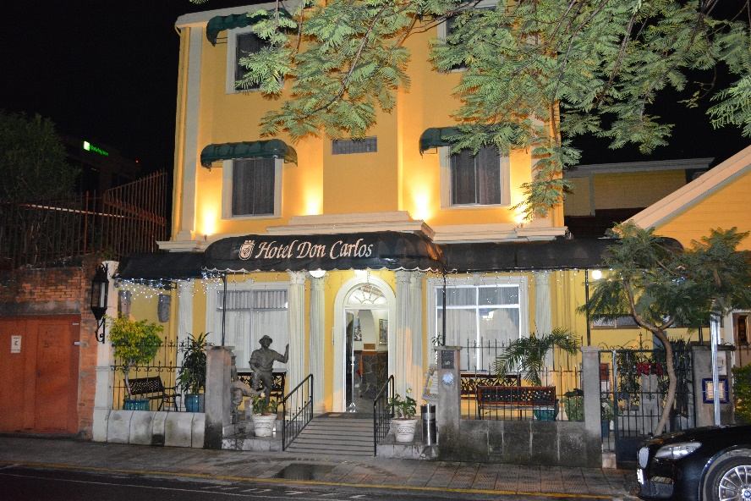

Day 2 – Sunday
After breakfast the group will depart 8:15 a.m. for Samasati Nature Retreat near Puerto Viejo. We will pass through the chilly heights of Braulio Carriollo National Park, the steamy lowlands of Guapiles, the Caribbean port town of Limon, many banana plantations and then follow the palm fringed coastal road south by the beach of Cahuita to Puerto Viejo.

We will arrive in time for lunch. The food is vegetarian and each meal is a treat. A gentle yoga class will be offered every evening from 5:30-6:45 p.m. followed by dinner in the open air restaurant.

The intention is to give a gentle and peaceful practice after a long day. The beautiful studio, the sounds of the rainforest and the gentle cueing will ease you into a rhythmic flow of meditative movement to transition to a blissful state of be-ing. (B/L/D)

Day 3 – Monday
After a slow flow vinyasa yoga class from 6:30-7:45 a.m. and breakfast, the group will head out for a morning excursion. At the Jaguar Animal Rescue Center you will have the opportunity to encounter monkeys and see a wide variety of animals up close. Sack lunches will be provided so you can enjoy a picnic on the beach. The beach at Punta Uva is claimed to be one of the best beaches in the area.

The group will return to Samasati after some beach time and an hour stop in the town of Puerto Viejo to shop. Evening yoga will be offered followed by dinner. (B/L/D)

Day 4 – Tuesday
After yoga and breakfast, we will transfer to a local woman’s home, the founder of El Yue. El Yüe is a women’s group initiative organized since 1994 in the Carbon 1 Community. As banana and vegetables growers, they started developing alternative activities that could allow them to improve their standard of living and be eco-friendly. We will participate in the process of making chocolate during our visit.

The afternoon will be spent at our Girls for Success Center with the children (ages 7-12) doing a variety of activities, including teaching English, reading books, doing a craft project, and implementing educational enrichment stations. We welcome any ideas based on your talents and interests. The idea is to share some of your own unique experiences while perhaps helping inspire the girls to continue with education and exploration. We encourage interaction and co-creation over gift giving. Please give the gift of your time and passions. (B/L/D)

NOTE: If our group is over 15 people, we will be divided into two so half the group will go to the animal rescue center/beach on Monday and the other half will go to the girls’ center. The groups will switch on Tuesday.

Day 5 – Wednesday
Following yoga and breakfast, you have two choices. You can either head out for a
Canopy Adventure or take part in an excursion to the Volio Water Fall.

Canopy Tour
The tour takes place over-looking the jungle where you will zip from tree to tree. There are 13 stations where you will enjoy approximately two hours of zip lining and walking in between several of the platforms. It’s an adventure that should be on everyone’s bucket list for at least once in life. Return to Samasati in time for lunch.

Volio Waterfall Hike
The Volio Waterfall is located within the Bribri Indian Reservation. There is a moderate hike to reach the waterfall, which is located in the Talamancan forests. The hike has several river crossings and the opportunity to view many different species of flora and fauna. Once you arrive to the refreshing blue/green waters, we will hike, swim, take pictures, relax and enjoy. Return to Samasati in time for lunch.

You will have the opportunity to dine in the home of one of the students from the Girls for Success Project as an alternative to having dinner at Samasati. Dinner with the families is an opportunity to see real Costa Rican life, speak Spanish, and make lifelong friends. Our past retreat guests say it was one of the highlights of the trip and creates lasting authentic connections. (B/L/D)

Day 6 – Thursday
After yoga and breakfast, we will have a morning adventure at the nearby Cahuita National Park. It is known for white sand, palm tree lined beaches, and crystal clear blue waters. You will have the opportunity to hike the flat seven kilometers to the point, swim, sunbath, and/or spend time in the small town of Cahuita shopping.

Return to Samasati for lunch and relax or participate in other activities. Taxis can be arranged in the afternoon to go to town for shopping and exploring. Or you can hike one of the many trails, get a massage, relax in the Jacuzzi, take a nap or read in a hammock.

The rest of the day is at your leisure. Enjoy yoga prior to our special farewell dinner at Samasati. (B/L/D)

Day 7 – Friday
After yoga and a leisurely breakfast, we will transfer mid-morning to San Jose and check-in at the Hotel Don Carlos again. There are local markets and museums to explore.

OR sign-up for an optional White Water Rafting excursion on your return trip to San Jose. The Pacuare River is world famous for its beauty. A true river gorge, it is flanked by steep, green walls. You will see waterfalls cascade into the river from both sides. Wildlife is abundant. It is not an overly challenging river, but it has many rapids that will make your adventure very interesting and fun! The 18-mile-one-day-run includes 38 rapids. Few rivers in the world can offer you so many rapids in such a short stretch of water. National Geographic has named it one of the top ten river rafting trips in the world. $99 per person

A Farewell Dinner is scheduled at local restaurant, Café Mundo, where you will be able to enjoy your last evening with your new found friends. (B/L/D)

Day 8 – Saturday
After breakfast, transportation will be arranged based on your return flight home. We hope you return home rejuvenated and inspired by all you experienced. (B)
Accommodations:
Samasati Nature Retreat - This stunning retreat is located on a 250 acre biological reserve overlooking the Caribbean. Just over 230 miles south of San Jose, it is an easy and naturally stunning commute from the airport. Sitting amidst the famous Costa Rican rainforest, your bungalow offers some of the most unique views of the Caribbean Sea. The retreat features yoga studios, Jacuzzi, sundeck, cocktail bar, open air restaurant, and massage therapists on staff. Samasati offers an array of activities for nature lovers, yogis, and anyone looking to relax in an exotic environment. Guests will also have access to in-house spa treatments and complimentary coordination of eco-tours and bird watching.

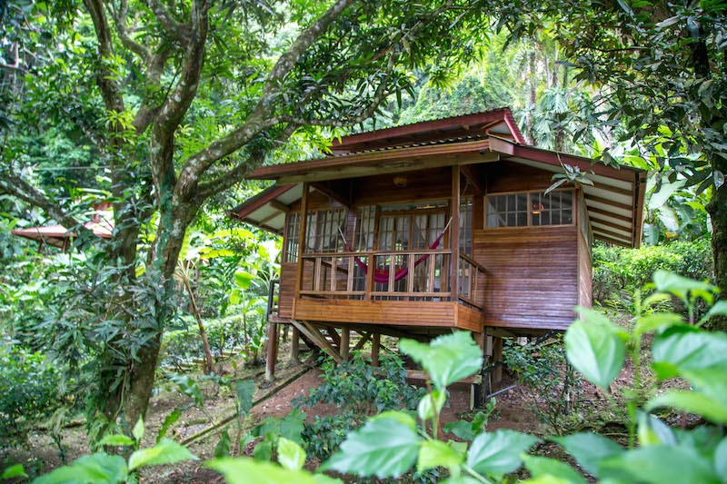
Inclusions:
- Five night accommodations – private bungalows at Samasati
- Two nights at the boutique Don Carols Hotel in San Jose
- Airport Transfers
- In-country transportation
- All meals at Samasati Nature Retreat
- Welcome and Farewell Dinners in San Jose
- Breakfast at Don Carlos
- Entrance into the Jaguar Animal Rescue Center
- Beach time at Punta Uva
- Dinner with a local family
- Nine yoga sessions at Samasati
- Cahuita National Park
- Chocolate Tour
- Zip-lining Adventure or Waterfall Excursion
- Coordination of all volunteer activities
- Services of Trip Leaders

Note: Additional destination information will be send to each participant no later than 60 days prior to departure. This information will including packing tips and also items or supplies needed at our girls’ center.

Prices:
Double Per Person: $1399 Bungalow
Triple Per Person: $1299 Triple Bungalow (two story bungalow with three beds)

Not Included:

- Air fare to Costa Rica
- Tipping of guides, drivers, and staff at Samasati (approximately $50 total)
- Personal expenses like massages and alcoholic beverages

Documents Needed: Passport

To guarantee your space, call our Reservation Manager, Susie Morwick at 317-544-8391 or email to susie@peacethroughyoga.org. A $500 deposit is needed to hold your space and the balance is due 90 days prior to departure.
We highly recommend travel insurance which Susie can also confirm for you.

TRIP LEADERS

Lynda Schoberth

Lynda is a graduate in Communications from DePaul University, Chicago, IL. She holds a 500-hr certification in Samapati yoga. Lynda spent 17 years working in the corporate world before she shifted completely to sharing the gift of yoga with her community in Chesterton, Indiana. In 2013, Lynda opened Bleu Lotus Yoga and offered her love of yoga to the community for six years.

Lynda is on the Board of Directors at Peace through Yoga Foundation. She is the Director of Sponsorships. One of the key elements to the stability of the foundation is the sponsors who are matched with one of 16 girls. The Girls for Success program is all that embodies what Lynda hopes for any girl…to be empowered and reach their potential.

Maryjane Behforouz

Maryjane is passionate about connecting people across cultures and contexts. She often states, “The deepest understanding of “other” is when you immerse yourself into the life and thoughts of another person. By going to ‘their country’ literally or figuratively, you find shared truths and greater understanding. The distance between self and other diminishes while compassion grows.” She believes purposeful travel is a peace-building endeavor, which is why her travels have taken her to six of the seven continents with a concentration in the Middle East.

As the founder of Pedal for Peace and a board member of a peace building school in Nazareth, Israel, Maryjane raised awareness and substantial funding by connecting her local community to the school’s mission. See C-SPAN'S Q&A with Maryjane to learn more. She has also led commercial adventure trips around the world with her National Outdoor Leadership School (NOLS) and Wilderness First Responder training. Maryjane has a Master’s in Organization Development and has owned a consulting business that supported contractors in the building of healthy homes and offices utilizing her certifications in Building Biology and the US Green Building’s LEED certification. As an expert in the field, she gave televised interviews on HGTV’s Living Fresh and on Discovery Health’s Living Green.

After practicing yoga for the last twenty years, she completed a 200-hour yoga teacher training through Yoga Alliance. Welcoming people of various religious traditions to share in this embodied approach to spirituality is something she cherishes.

Maryjane looks forward to sharing meaningful adventures with other curious souls who desire to enrich their lives and the lives of others!

“Travel is fatal to prejudice, bigotry, and narrow-mindedness…” -Mark Twain “The shortest path to oneself leads around the world.” -Hermann von Keyserling

